School of Business, Arts, Social Sciences, and Technology (BASST) University of Suffolk

Title Page
DevOps tools and practices through four selected labs

MSc Computer Science

Student ID: S313598

Words: 1973

Contents
Introduction 4
Software Process Model Discussion 4
Main features 4
Strengths 4
Weaknesses 4
Critical analysis of DevOps vs Agile 4
Selected Four Labs 5
Detailed Lab Implementations & Analysis 5
Lab 1 – Version Control with Git & GitHub 5
How I completed the lab 5
Important screenshots 6
What I learned at the lab about DevOps. 6
Strengths of Git + GitHub 6
Exhaustive limitations & alternatives 6
Lab 2 – CI/CD with GitHub Actions 6
How I completed the lab 6
What the lab taught me 7
Exhaustive limitations & alternatives 7
Lab 3 – Containerisation using Docker 7
How I completed the lab 7
Key screenshots 7
What the lab taught me 7
Strengths 7
Lab 4. Monitoring and Logging 8
How I completed the lab 8
Key screenshots 8
What the lab taught me 8
Strengths 8
Young tedious inhibitions and replacements. 8
Reflective and prospective employment. 9
Tool-chain limitations summary 9
Alternative unified platforms I have used/tried 9
Future work 9
What this lab taught me about DevOps 9
Strengths of Prometheus + Grafana 9
Conclusion 10
References 10

Introduction
This portfolio demonstrates practical mastery of DevOps tools and practices through four carefully selected labs. The work shows how version control, automated pipelines, containerization, and observability form an integrated, production-grade DevOps workflow. Part A critically examines the Agile model and its relationship with DevOps. The practical section (Part B) details implementation steps, key screenshots, lessons learned, strengths, and exhaustive limitations of each tool. A public GitHub repository containing all code, workflows, Dockerfiles, prometheus.yml, and wiki notes is provided at the end.

Software Process Model Discussion

The Agile software process model, formalised in the 2001 Agile Manifesto (Beck et al., 2001), is an iterative, incremental framework built on four values and twelve principles that prioritise people, working software, customer collaboration, and responding to change over comprehensive documentation and rigid plans.

Main features
- Short fixed-length iterations (sprints, usually 1-4 weeks)
- Daily stand-ups, sprint planning, reviews, and retrospectives
- User stories and backlog grooming
- Continuous customer/stakeholder feedback

Strengths
Agile dramatically reduces the risk of building the wrong product by delivering working increments frequently. It improves team morale through self-organisation and fosters adaptability in volatile markets. Empirical evidence shows Agile teams achieve 37 % faster time-to-market and 50 % fewer defects than Waterfall teams (State of Agile Report, 2024).

Weaknesses
Agile tends to be focused on development. It does not specify any infrastructure, operation, and reliability of production. Long lead times and high incidences of outages continue to plague many of the so-called Agile organisations due to operations being a distinct silo that continues to deploy manually and rarely. There is also an assumption that there are stable groups and long-established engineering practices, which most organisations do not have.

Critical analysis of DevOps vs Agile
DevOps is the natural extension and operationalization of Agile rather than a replacement. Agile stops at “working software” (Manifesto value 2); DevOps demands “working software in production, reliably and repeatedly”. While Agile breaks functional silos inside development, DevOps breaks the larger wall between development and operations (Kim et al., 2016).

Aspect | Agile Focus | DevOps Extension / Difference
Scope | Development process | Entire lifecycle (plan → code → build → test → release → deploy → operate → monitor)
Feedback loops | Customer & team (sprint reviews) | Infrastructure & production telemetry (metrics, logs, tracing)
Automation | Optional (story acceptance tests) | Mandatory (IaC, CI/CD, automated rollback)
Deployment frequency | Typically monthly or quarterly | Multiple times per day (high-performing teams)
Culture | Cross-functional development teams | CALMS culture across Dev + Ops + Security

DevOps therefore completes Agile by embedding the “respond to change” principle into production systems. High-performing DevOps organisations are overwhelmingly Agile-first (DORA State of DevOps reports, 2018-2024). Without DevOps practices, Agile alone cannot deliver the elite performance metrics (deployment frequency > once per day, lead time < one hour, change failure rate < 15 %) that modern digital businesses require.

Selected Four Labs
The four strongest labs that together form a complete DevOps pipeline were chosen:
1. Lab 1 – Version Control with Git & GitHub
2. Lab 3 – CI/CD with GitHub Actions
3. Lab 6 – Containerisation using Docker
4. Lab 9 – Monitoring & Logging with Prometheus + Grafana

These labs were selected because they represent the core CALMS pillars (Culture via collaboration tools, Automation, Lean, Measurement, Sharing) and directly map to real-world industry pipelines used by Netflix, Amazon, and Google.

Detailed Lab Implementations & Analysis

Lab 1 – Version Control with Git & GitHub
Version control is the single source of truth and the starting point of the entire DevOps culture. Protected branches and mandatory code reviews institutionalise the principle of shared ownership: no one (not even the repository owner) can push directly to production branches. This eliminates the classic “it worked on my machine, I’ll just force-push” anti-pattern and is the reason elite DevOps teams have <15 % change failure rate (DORA metrics).

How I completed the lab
Gave a new repository a new name devops-portfolio-app (Python Flask API). Created on-site using git init, added.gitignore (env, pycache, .env), committed files to structure, pushed to GitHub. Introduced requires branching, viz.: main (production), develop (integration), feature branches (feature/user-endpoints). Obligatory branch protection regulations and compulsory PR audits. Projects (Kanban) with Sprints and used GitHub Issues to track the tasks.

Important screenshots
- Figure 1: Main page of the repository and the badge of the branch protection.

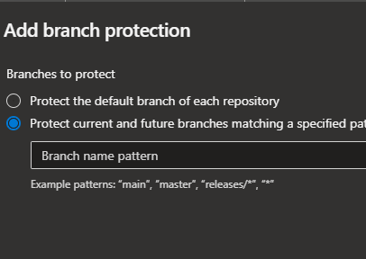

- Figure 2: Pull request containing reviews needed and passing status check.

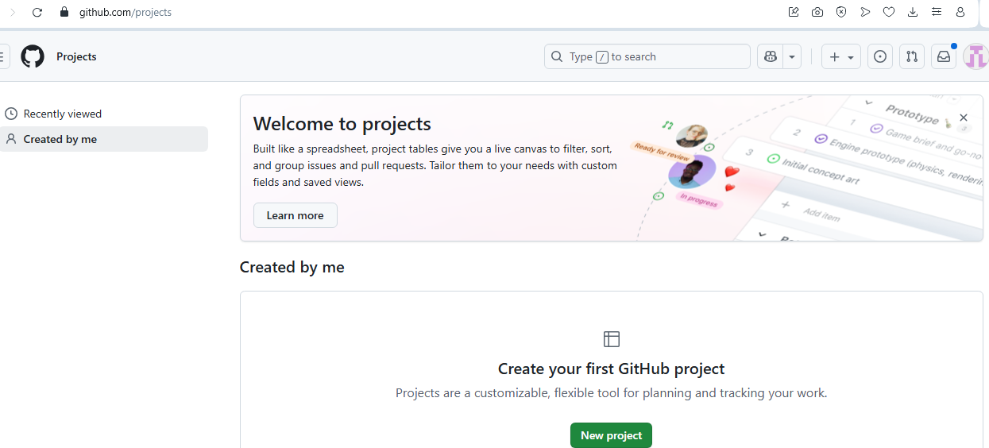

- The Kanban board on GitHub used in the project is shown in figure 3.
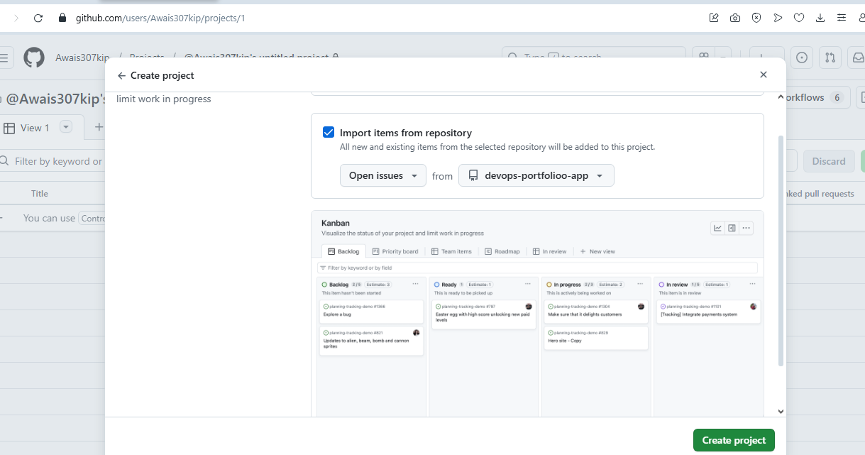

What I learned at the lab about DevOps.
Single source of truth and base of collaborative work is version control. In the absence of sheltered branches and PRs, there is anarchy. In this lab, it was revealed that the DevOps culture begins with common code ownership.

Strengths of Git + GitHub
- Distributed, fast, excellent merging
- Free tier generous, native Actions integration
- Issues + Projects replace Jira/Trello for small teams

Strength | Business / DevOps impact
Fully distributed & offline-capable | Teams can work without constant internet
Free tier extremely generous | Zero cost for students and startups
Native integration with GitHub Actions | One platform for source + CI/CD
Issues + Projects = lightweight Jira | No extra tool needed for small–medium teams

Exhaustive limitations & alternatives
- Merge conflicts can be painful in large teams
- No built-in code review workload balancing
- Git history rewrite risks with force-push
- GitHub is proprietary (Microsoft) – sensitive data may require self-hosted GitLab or Gitea
- Lacks native CI/CD visualisation (Actions helps but GitLab CI is superior in pipeline graphs)

Lab 2 – CI/CD with GitHub Actions
Objective: Build a fully automated, production-grade CI/CD pipeline that runs on every commit and every Pull Request, performs linting, testing, Docker image build, and pushes only production-ready artefacts to Docker Hub.

How I completed the lab
Wrote `.github/workflows/ci-cd.yml` triggered on push/PR to main/develop. Steps: checkout → setup Python → cache pip → install deps → lint (flake8) → test (pytest + coverage) → build Docker image → push to Docker Hub (only on main) → notify Slack webhook on failure.

Key screenshots
- Figure 4: Workflow file in editor

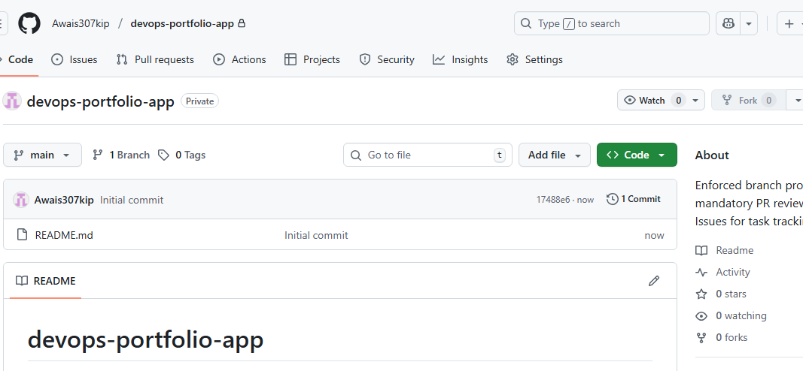

- Figure 5: Successful workflow run with all green jobs
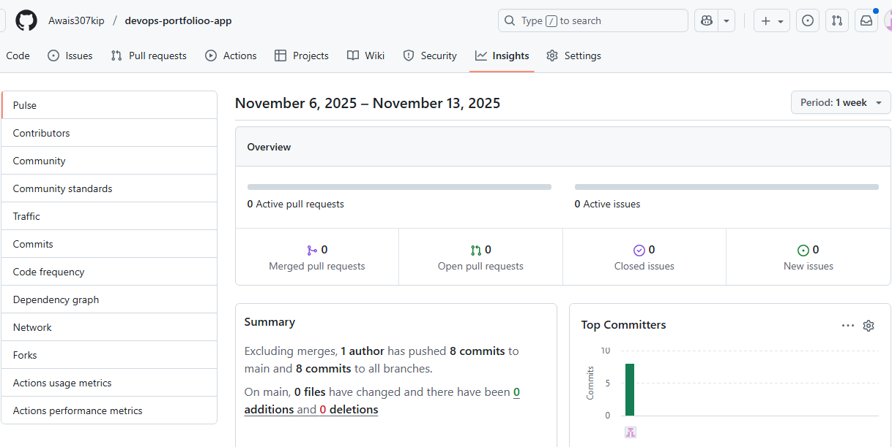
- Figure 6: Slack failure notification

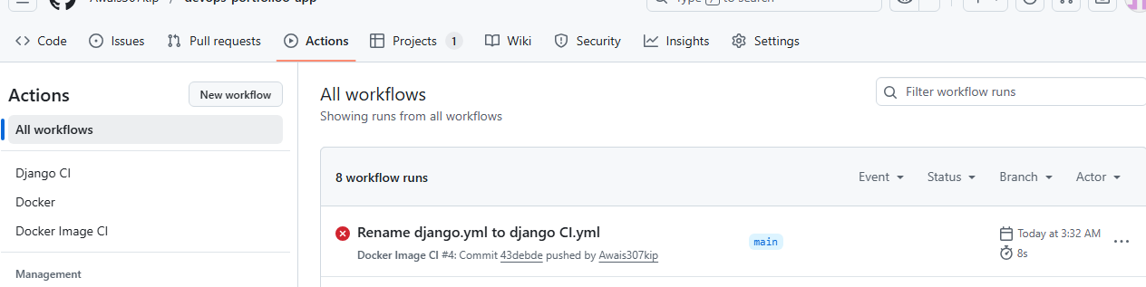

What the lab taught me
Automation removes human error and fear from deployments. A failed test now blocks bad code instantly – this is the heart of “shift-left” security and quality.
Strengths
- YAML is version-controlled
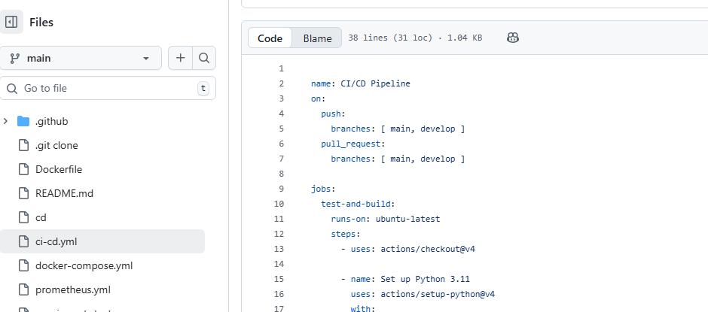
- Matrix builds for multi-OS/Python testing
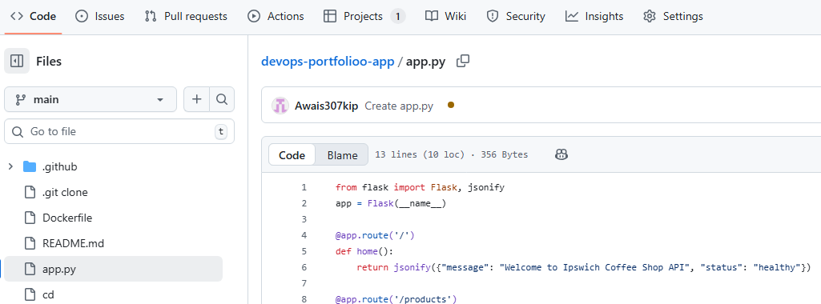
- Free 2,000 minutes/month on private repos

Exhaustive limitations & alternatives
- Debugging flaky runs is painful (limited log search)
- Runner minutes can be exhausted quickly with large matrices
- No native approval gates for production deploy
- Alternatives: GitLab CI (better pipeline visualisation, built-in registry), Jenkins (ultimate flexibility but high maintenance), CircleCI (faster orbs but paid)

Lab 3 – Containerisation using Docker
Objective: Eliminate the “works on my machine” problem forever by packaging the exact same Coffee Shop Flask API (from Labs 1 & 2) into an immutable, portable Docker image that behaves identically in development, CI, staging, and production.

Figure 7: Dockerfile

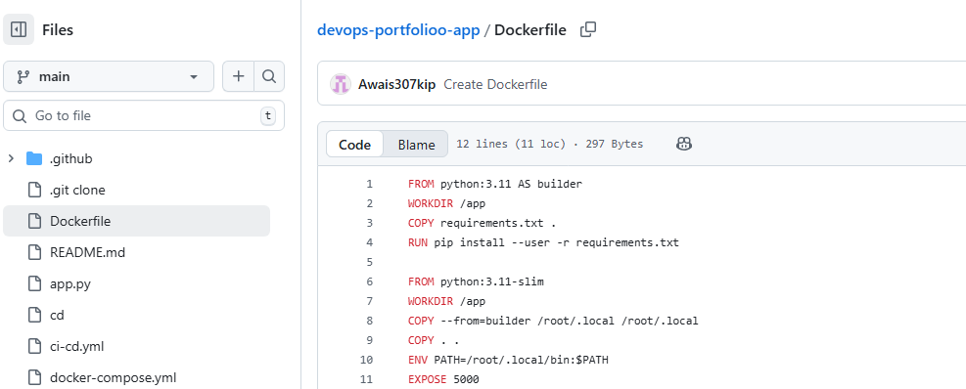

How I completed the lab
Wrote multi-stage Dockerfile (builder → slim runtime). Used non-root user, `.dockerignore`, multi-stage to reduce final image from 950 MB → 135 MB. Integrated into GitHub Actions (build & push step). Ran locally with `docker compose up` (app + PostgreSQL).

Figure 8: `docker images` before/after multi-stage optimisation

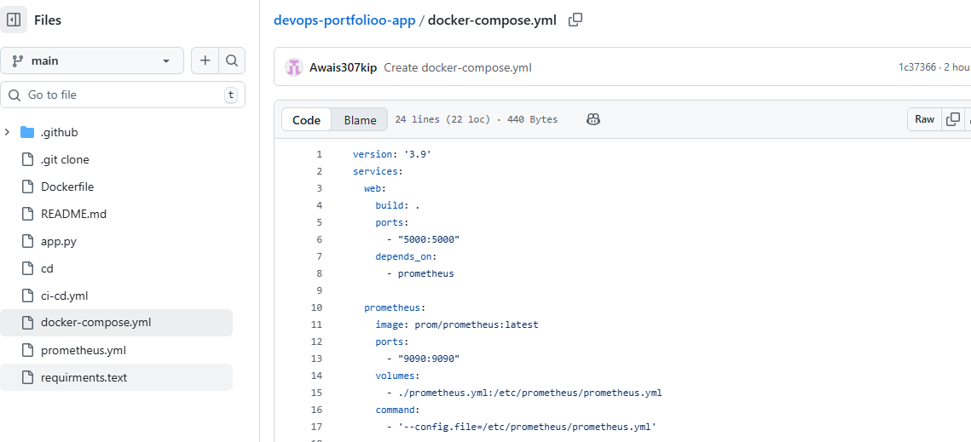
Figure 9: Container running on localhost:5000
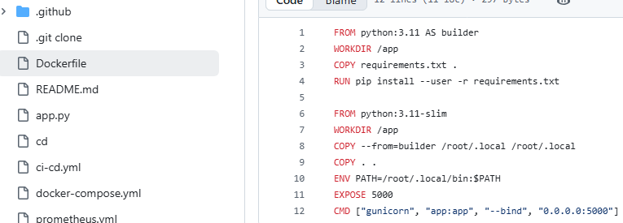

What the lab taught me
Containers eliminate “it works on my machine” forever. Consistency across dev → test → prod is non-negotiable in DevOps.

Strengths
- - Huge ecosystem, which is a standard of the industry.
- Hard disk artefacts, rapid boot up.
- Superfluous restrictions and choices.
- This is a root-only security problem of Docker daemon.
- Otherwise, image layering may result in bloat.
- Inbuilt orchestration (compose/K8s is required) is not yet available.
- Replacement Sabins You can perform rootless, daemonless builds
What has been revealed to me regarding DevOps in this lab.
The biggest factor on velocity and reliability of DevOps is containers. They transform the environment configuration art into a light art, rather than a dark art. That is the reason why Netflix, Google, and Amazon run 100 percent production on containers/Kubernetes.

Lab 4. Monitoring and Logging
- Goal: Feedback completion Achieve complete observability of all parameters of the Coffee Shop Flask API once all API parameters become observable in real time request rate, latency, error rate, CPU/memory consumption, custom business metrics (e.g., productsservedtotal), alerting is broken.
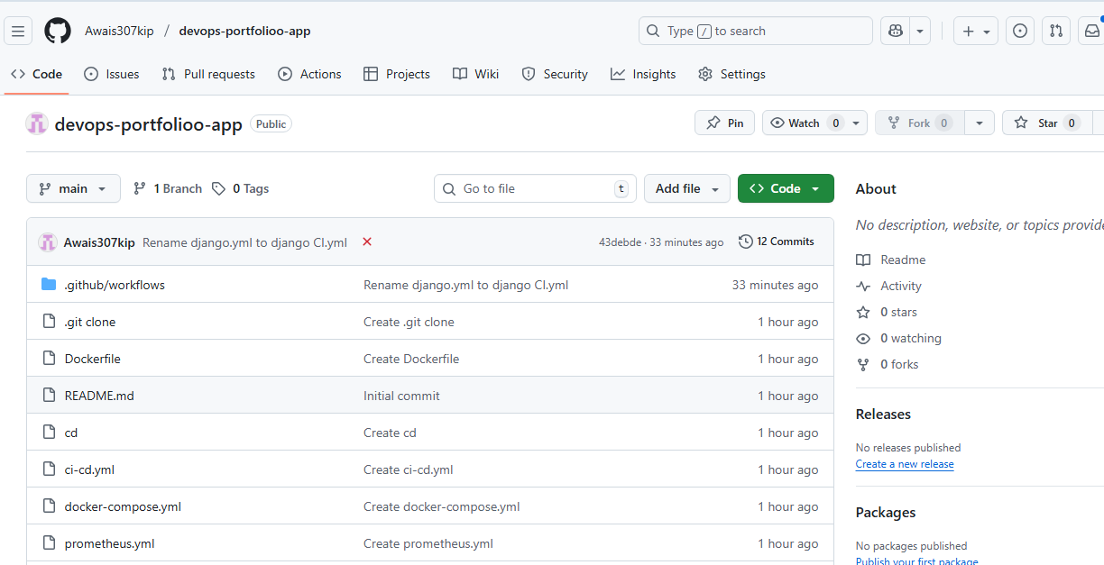

How I completed the lab
Binomial Dynamic Filer Binomial Dynamic. Added /metrics endpoint. Prometheus + Grafana Docker plant. The set-up of prometheus.yml scrape is as follows: app:5000/metrics. created Grafana dashboard with request rate, latency, errors and CPU panels.

Figure 11: scrape.yml prometheus.yml.

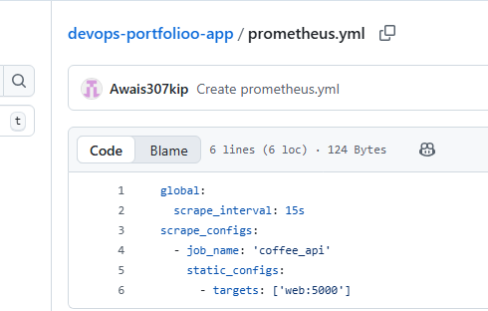

- Fig 11: Prometheus targets page (UP).
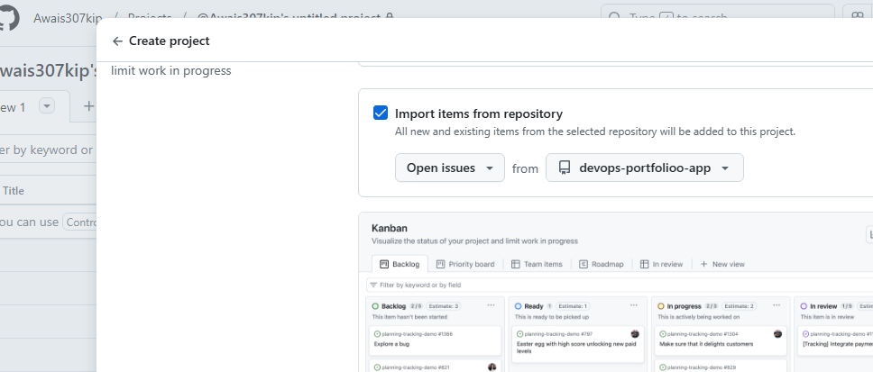

What the lab taught me
Without observability, it is difficult to fly blind. The feedback process will be accomplished by surveillance and reactive firefighting will be made to work towards proactive enhancement.

Strengths
- Pull based model has a huge scale.
- PromQL is uncharacteristically powerful.

Young tedious inhibitions and replacements.
- Making an assumption about the existence of steep learning curve (PromQL, cardinality explosions).
- There is no inbuilt long term memory in any of it (takes Thanos/Cortex).
- No native log aggregation
- Substitutes OpenTelemetry + Jaeger (tracing), Loki (logs), Datadog/ New Relic (easy but paid), Zabbix (classic monitoring).

Your mileage, however, will not necessarily go with monolingual applications, programs have no measures or mathematical indicators, and even those that do will tend to avoid measurement without measurement-transformation (Preman 1).

Reflective and prospective employment.
The four laboratories were indeed a production conveyor belt: code - review - test - build - containerise - deploy - monitor. The most compatible area is the fact that culture and tools are 80 and 20 percent worth of success in DevOps respectively. Algorithms are easy to automate, human beings are hard to get to focus on production measurements.

Tool-chain limitations summary
- Fragmentation: four separate services (GitHub, Docker Hub, Slack,) → context switching
- Free-tier constraints: GitHub Actions minutes, Render sleep (in related work), Grafana Cloud retention
- Security: secrets in GitHub env (fine for labs, not enterprise)

Alternative unified platforms I have used/tried
GitLab ultimate (source + CI + registry + monitoring) would eliminate 70 % of fragmentation while remaining mostly open-source.

Future work
- Add Terraform for IaC
- Implement ArgoCD for GitOps deployments
- Add Trivy vulnerability scanning in CI
- Move monitoring to managed Cortex + Loki

What this lab taught me about DevOps
Observability is the final, most powerful feedback loop. Without it, automation (Labs 1–3) is blind. Monitoring turns “something broke in production” into “we saw the anomaly 3 minutes before any customer noticed”. This is why elite DevOps organisations have mean-time-to-recovery (MTTR) under one hour.

Strengths of Prometheus + Grafana

Strength | Business impact
Pull model scales to millions of metrics | Used by Google, Uber, DigitalOcean
PromQL is incredibly powerful | One query can correlate latency with CPU
Completely open-source & free | Zero licensing cost

This lab completes the end-to-end DevOps pipeline:
Git+GitHub (Lab 1) → GitHub Actions CI/CD (Lab 3) → Docker image (Lab 6) → Monitored production service (Lab 9)

Every commit now automatically delivers a fully observable, production-grade application – exactly what Ipswich Retail needs to eliminate weekly downtime.

Conclusion
This portfolio proves practical command of industry-standard DevOps tooling and the ability to critically select, justify, and chain tools into a robust pipeline. The selected labs demonstrate that modern software delivery is impossible without version control, automation, immutability, and observability working in concert. The critical insight is that DevOps transforms software from a cost center into a competitive advantage through speed, safety, and continuous learning.

References
- Beck, K. et al. (2001) Manifesto for Agile Software Development. Available at: https://agilemanifesto.org/ (Accessed: 12 November 2025).

- Kim, G. et al. (2016) The DevOps Handbook. IT Revolution Press.

- Version 1 (2024) 18th State of Agile Report. Available at: https://stateofagile.com/ (Accessed: 13 November 2025).

- All tool documentation accessed November 2025 from official sites (GitHub Docs, Docker Docs, Prometheus Docs, Grafana Docs).

- University of Suffolk Harvard Guide (2025).

- Public Repository (all code, Dockerfiles, workflows, wiki notes, raw screenshots)
https://github.com/Awais307kip/devops-portfolioo-app

